CLIENT & PRODUCT INFORMATION
Please use one form for each product
If possible, please use MS Word or Adobe Acrobat to complete this form and send an electronic copy by email (KVAFL@KSU.EDU). When sending your product, please include a hard copy of this form with your product.

Name: Date:

Company:

Address:

City: State: Zip:

Phone (work): (home/cell):

E-mail: Product Name:

From the Land of Kansas member: ☐ YES (must request our services) ☐ NO

Please email a copy to kvafl@ksu.edu for us to review BEFORE YOU SEND YOUR PRODUCT. After review and adjustments, we will send you shipping information and instructions.

Select Testing | Description  (Payment required prior to testing unless otherwise noted) | Kansas Clients | Out-of-State Clients
☐ | Process Authority Letter & Nutrition Facts Label Combo  This includes pH, Aw, and sodium testing. Other tests will cost extra. | $200 | $400
☐ | Process Authority Letter only | $150 | $300
☐ | Nutrition Facts Label only | $150 | $300
☐ | pH (acid content) | $20 | $40
☐ | Water Activity | $20 | $40
☐ | Sodium Content | $20 | $40
☐ | % Brix | $20 | $40
☐ | Moisture Content | $50 | $100
☐ | Gluten Testing | $100 | $200
☐ | Instrumental Color Evaluation | $100 | $200
☐ | Alcohol Content Test | $150 | $300
☐ | Shelf Life Study (Please contact us for guidance. You will be invoiced after testing)
☐ | Microbial Testing (Please contact us for guidance. You will be invoiced after testing)
☐ | Other (Please contact us for guidance and cost)
FORMULA INFORMATION*
PLEASE TYPE THIS INFORMATION, DO NOT HAND WRITE. THANKS!

Product Name:

Brand of Ingredient  (e.g. Heinz, Members Mark, Hunts, etc.) | Specific Ingredient  (include form e.g. fresh, dried, chopped, whole, etc.) | Ingredient Weight or Volume ONLY  (e.g., pounds, ounces, grams, fluid ounces, milliliters) | Ingredient Sub-Ingredients  (Include all ingredient components, e.g., tomato concentrate from red ripe tomatoes, distilled vinegar, high fructose corn syrup, frozen, fresh or canned ingredient)

* Provide details, such as the brand name, specification sheets, nutrition profiles, and nutrition facts panels for each ingredient to expedite the generation of your Nutrition Facts Panel. Use more than one page, if necessary, or provide other documentation. You may be asked to contact your ingredient supplier to provide additional nutritional information for label accuracy. We will contact you if more information is needed.
PROCESSING INSTRUCTIONS
PROVIDE A DETAILED DESCRIPTION OF YOUR PROCESS—INCLUDING TEMPERATURE (measured by thermometer), TIME INFORMATION, AND THE TYPE OF RETAIL CONTAINER FOR THE PRODUCT. Include all processing parameters such as temperature, holding time, inverting the container after filling, etc. If the container is plastic, indicate the maximum temperature the plastic can withstand. Please use as many pages as necessary to provide a thorough description of your food product process.
Product Name:
Type of Container  (e.g. glass bottle, plastic bottle) | Plastic Container Maximum Fill Temperature  (if applicable) | Product Fill  Volume or Weight | Container Size | Type of Container Lid  (e.g. 1-piece plastic, 2-piece lid)
Processing Instructions: please provide as much detail as possible

For Nutrition Facts Label, please select the label format needed for your package.*
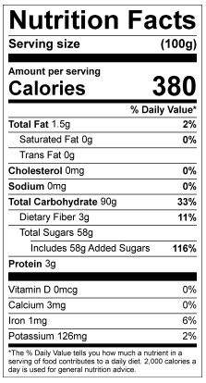
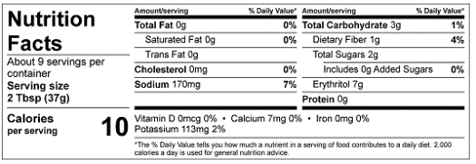
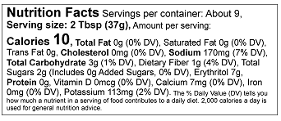
☐ ☐ ☐

Tabular Label
Option for package with 40 sq. in. or less total surface area for labeling

Linear Label
Option for package with 40 sq. in. or less total surface area for labeling

Standard Label
For package with 40 sq. in. or
more total surface area for labeling

*Some products may require a dual column label, which will be communicated to you once it has been determined. This is done at no additional charge. Some labels may qualify for a simplified label format for no additional charge.

Please refer to “Food Labeling for Kansas Food Producers and Processors – MF3385” on our website (ksre.ksu.edu/kvafl) for more information on nutrition labeling. Label format will depend on label size. More details can be found in the “FDA Food Labeling Guide.”

KEEP COPIES OF ALL SUBMITTED PAPERWORK FOR YOUR REFERENCE!

General Information:
Please be aware that your company is solely responsible for the content and accuracy of your labeling and Kansas State University assumes no liability for your use of the nutrition facts labels. By submitting this application and engaging us to calculate the labels, you expressly agree to hold harmless and indemnify Kansas State University, the State of Kansas, the Kansas Board of Regents, and all their agents, officers, and employees, from all claims, demands, and causes of action of any kind that may arise as a result of its performance of these activities.

Confidentiality Notice:
All formulas, concepts, ideas, and/or other intellectual property of KVAFL clients shall remain confidential, and will not be used by KVAFL employees, or other Kansas State University students, for personal gain unless agreed upon by both parties.

